Duality AI Hackathon Report
Offroad Semantic Scene Segmentation

Team Name: BEARS
Project Name: Offroad Scene Segmentation using DeepLabV3
Tagline: "Improving off-road perception using deep learning and synthetic data."
Project Summary:
This project focuses on training a semantic segmentation model to identify different objects in off-road desert environments. The model was trained using synthetic data provided in the hackathon dataset and tested on unseen environments to measure how well it performs in new locations.
We used the DeepLabV3 architecture to classify every pixel in an image into categories such as trees, bushes, rocks, logs, ground clutter, and sky. The aim was to improve the model’s accuracy and increase its ability to recognize objects even in difficult conditions.
The model started with an initial IoU score of 0.3765 and was improved through training, tuning, and problem-solving to reach a final IoU score of 0.5904729388937165.
This documentation explains:
- How the dataset was prepared
- How the model was trained
- What challenges were faced
- How performance improved over time

METHODOLOGY
Step-by-Step Process
1 Dataset Preparation
- Downloaded the segmentation dataset from the Falcon platform.
- The dataset contained:
  - RGB training images
  - Segmentation masks(grayscale)
  - Validation images
  - Test images from a new environment
The images included 10 different desert objects such as(which is our classes):
Semantic Classes (10)
- Background / Sky
- Sand / Terrain
- Bushes
- Trees
- Rocks
- Logs
- Grass
- Shrubs
- Uneven terrain
- Miscellaneous obstacles

2 Environment Setup
- Installed Anaconda to manage dependencies.
- Created the required environment.
- Installed all libraries using the setup script.
3 Model Selection
We selected DeepLabV3 because:
- It performs well for pixel-level classification.
- It captures fine object boundaries.
- It works effectively on complex outdoor scenes.
4 Training Process
Training was performed using mixed precision to maximize GPU utilization and reduce memory usage.
Key Training Details
- Image resolution: 512 × 768
- Batch size: 4
- Optimizer: AdamW
- Learning rate scheduling applied
- Loss function: Combined Cross-Entropy + IoU loss
- Early stopping used to prevent overfitting
Hardware Setup
Training was conducted on NVIDIA laptop GPUs:
RTX 4050 (6 GB VRAM) & RTX 4060 (8 GB VRAM)
Parallel experimentation allowed comparison of performance and training speed.

5 Fine-Tuning Steps
To improve performance:
- Increased number of training epochs.
- Adjusted learning rate.
- Used validation monitoring to prevent overfitting.
These steps helped increase the IoU score significantly.
RESULTS & PERFORMANCE METRICS

Key Performance Scores
Metric | Value
Initial IoU Score | 0.3765
Final IoU Score | 0.5905
Improvement | +0.214
Training Stability | Improved over time
Performance Analysis
- The model learned slowly in early training stages.
- After tuning parameters, performance improved steadily.
- The model became better at recognizing major classes like:
  - Trees
  - Bushes
  - Rocks
  - Ground regions

Graphs to Include (from runs folder)
- Training Loss vs Epoch
- IoU Score vs Epoch
- Accuracy Trend
These graphs show how the model improved during training.

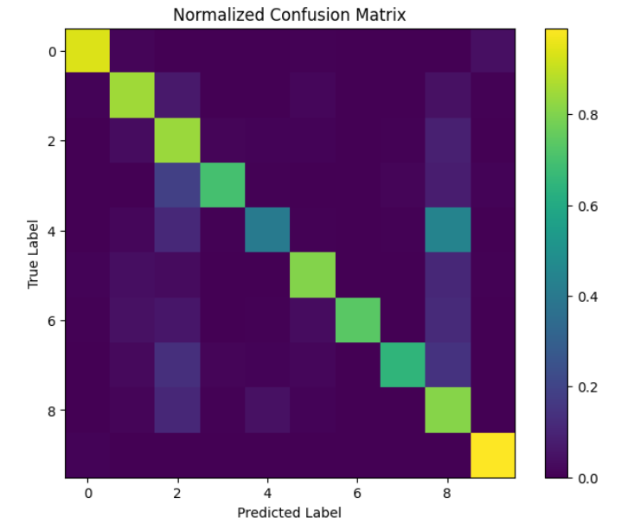
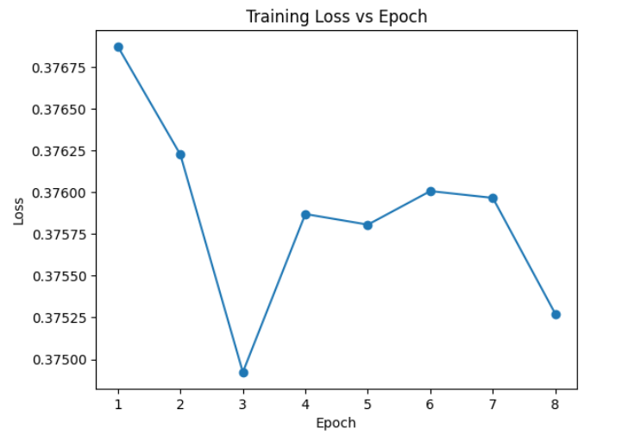
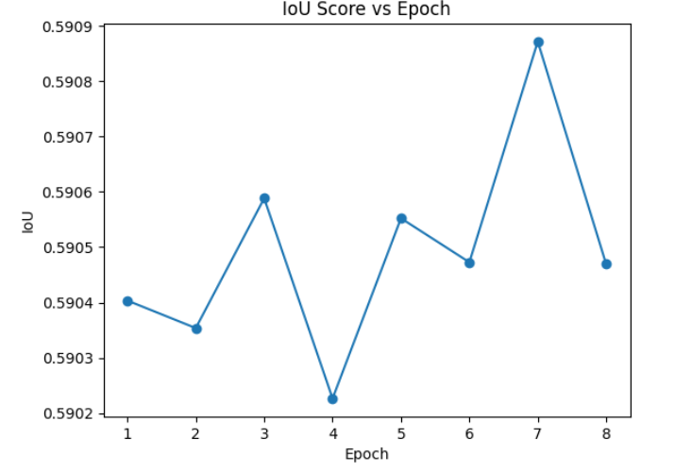
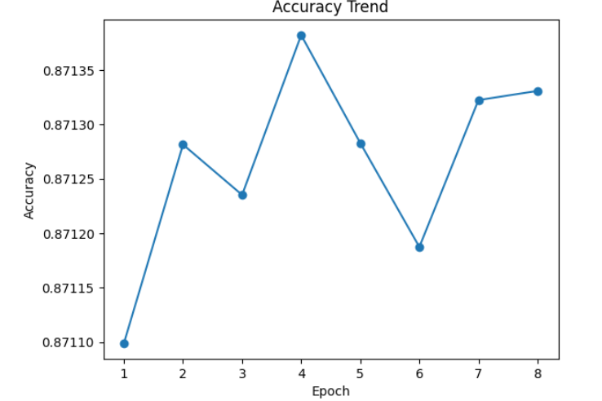
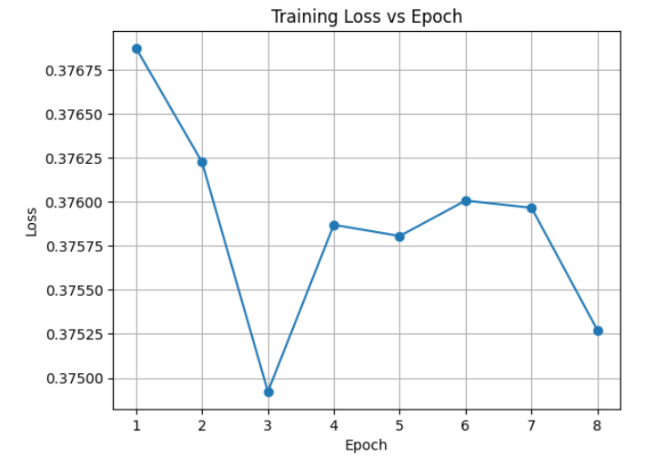
VISUAL RESULTS

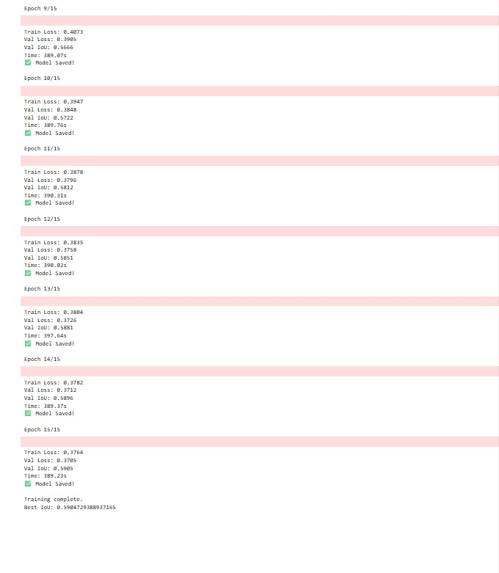

CHALLENGES & SOLUTIONS
Challenge 1: Low Initial Accuracy
Task: Model Training on Dataset
Initial IoU Score: 0.3765
Issue Faced:
The model struggled to detect smaller objects and mixed vegetation areas.
Solution:
- Increased training epochs
- Adjusted learning rate
- Allowed model to learn deeper features
Result:
IoU improved significantly during later training stages.

Challenge 2: Confusion Between Similar Classes
Issue Faced:
The model mixed up:
- Dry grass
- Dry bushes
- Ground clutter
These classes look very similar in color and texture.
Solution:
- Extended training time
- Allowed model to better learn texture differences
Result:
Class separation improved and IoU increased.

Challenge 3: Overfitting in Early Training
Issue Faced:
- Training accuracy improved fast
- Validation accuracy improved slowly
This indicated the model was memorizing instead of generalizing.
Solution:
- Used validation monitoring
- Reduced learning rate
- Continued balanced training
Result:
Model became more stable and generalizable.

4. Hardware Constraints
Limited VRAM required small batch sizes and careful memory optimization.
Solution: Mixed precision training enabled efficient GPU usage.

CONCLUSION & FUTURE WORK
Conclusion
This project successfully trained a DeepLabV3-based semantic segmentation model to understand off-road desert environments.
Key achievements:
Improved IoU from 0.3765 → 0.5905
- Better segmentation of trees, bushes, and terrain
- Model learned to generalize to unseen environments
This shows the effectiveness of synthetic datasets in training strong AI models.

Future Improvements
To further improve performance, we plan to:
- Try advanced architectures:
  - DeepLabV3+
  - UNet++
- Use data augmentation:
  - Rotation
  - Lighting variation
  - Occlusion simulation
- Improve detection for:
  - Logs
  - Small rocks
  - Ground clutter
- Increase dataset diversity for better generalization

